**Market Review and Trends: Smart Automated Classroom Attendance System Using Face Recognition**

**Market Overview:**

The education technology (EdTech) market has experienced significant growth, driven by the increasing adoption of digital tools in educational institutions worldwide. Automation and Deep Learning solutions are at the forefront of this transformation, offering innovative ways to enhance administrative efficiency, improve learning experiences, and ensure data accuracy. Among these solutions, automated attendance systems using facial recognition technology stand out as a promising development.

**1. Current Market Trends:**

**a. Growth in AI and Machine Learning:**

The integration of AI and machine learning in educational tools has been accelerating. Facial recognition, a subset of AI, is becoming increasingly popular due to its potential to streamline administrative tasks, such as attendance tracking, by providing a reliable and efficient solution. The global facial recognition market is expected to grow significantly, with a projected CAGR(Compound Annual Growth Rate) of around 16.6% from 2020 to 2027.

**b. Contactless Technologies:**

In the wake of the COVID-19 pandemic, there has been a surge in demand for contactless solutions across various sectors, including education. Facial recognition attendance systems provide a non-intrusive way to monitor student presence, reducing the risk of disease transmission and ensuring a safer environment for students and staff.

**c. Digital Transformation in Education:**

Educational institutions are increasingly embracing digital transformation to enhance operational efficiency and improve educational outcomes. Automated attendance systems are part of this broader trend, enabling real-time data collection and analysis, which helps in making informed decisions.

**d. Data Privacy and Security:**

With the growing use of biometric data, there is a heightened focus on data privacy and security. Ensuring compliance with data protection regulations, such as GDPR (General Data Protection Regulation) in Europe and FERPA (Family Educational Rights and Privacy Act) in the United States, is crucial for the successful deployment of facial recognition systems in educational settings.

**2. Competitive Landscape:**

**a. Established Players:**

Several established EdTech companies are incorporating facial recognition technology into their product offerings. Companies like NEC Corporation, Microsoft, and FaceFirst are known for their advanced facial recognition solutions. These companies provide comprehensive systems that include hardware and software for seamless integration into existing school infrastructures.

**b. Emerging Startups:**

Numerous startups are entering the market with innovative solutions tailored to specific educational needs. Companies like Trueface and Kairos are developing facial recognition technologies that are easily deployable in educational environments, offering features like real-time attendance tracking, visitor management, and even emotion recognition.

**3. Challenges and Opportunities:**

**a. Accuracy and Reliability:**

One of the primary challenges in deploying facial recognition systems is ensuring high accuracy and reliability under various conditions (e.g., different lighting, facial expressions, and occlusions). Advances in deep learning models and algorithms are continually improving accuracy rates, making these systems more viable.

**c. Ethical and Privacy Concerns:**

Ethical considerations and privacy concerns regarding the use of biometric data are significant. It is essential for developers and educational institutions to address these concerns transparently and ensure robust data protection measures are in place to gain the trust of users.

**d. Cost-Effectiveness:**

While the initial investment in facial recognition technology may be high, the long-term benefits, such as reduced administrative workload and improved accuracy, can justify the cost. Solutions that offer a good balance between cost and functionality are likely to see higher adoption rates.

**4. Future Prospects**

**a. Advancements in Technology:**

Future advancements in AI and machine learning are expected to enhance the capabilities of facial recognition systems further. This includes improved accuracy, faster processing times, and the ability to recognize individuals even with partial occlusions or in low-light conditions.

**b. Broader Adoption:**

As technology matures and becomes more affordable, broader adoption in educational institutions is anticipated. This includes not just K-12 schools and universities, but also vocational training centers and other educational facilities.

**c. Enhanced Features:**

Future systems may incorporate additional features such as emotion detection, behavioral analysis, and integration with other smart campus technologies to provide a more comprehensive solution for educational management.

## Key Milestones and Deliverables:

|  |  |  |  |
| --- | --- | --- | --- |
| **S. No.** | **Elapsed time since start of the project** | **Milestone** | **Deliverable** |
| 1. | Week 01 – 05 | * Requirement Gathering and Report * Functional and Non-Functional Requirement | * Finalization of requirements and report. * Functional and Non-Functional Requirements report finalization. |
| 2. | Week 06 – 11 | * Use Cases * Market Review * Machine Learning Pipeline | * Finalization of use cases, market review and machine learning pipeline |
| 3. | Week 12 – 14 | * ERD Diagram * Prototype * Project Budgeting | * Finalization of Class Diagram, ERD, Business Model Canvas, Prototype and project budgeting. |
| 4. | Week 15 – 20 | * University Student’s Data and additional relevant details. * Deep Learning approach for face recognition. | * Gathering Student’s data from various sources in university. * Implementing the Deep Learning approach for face recognition. |
| 5. | Week 21 – 24 | * A Deep Learning approach for Feature Extraction. | * Implementation of code using Deep Learning Feature Extraction one by one. |
| 6. | Week 25 – 28 | * Model Development. | * Implementation of Model. |
| 7. | Week 29 – 32 | * Insertion Query Implementation | * Implementing the Insertion Query. |
| 8. | Week 33 – 36 | * Database and Website integration. | * Integration of Database and Website Portal. |
| 9. | Week 37 – 40 | * CCTV set up for Face Detection and Segmentation. | * Setting up CCTV camera for face detection and segmentation. |
| (Please add more rows if required.) | | | |

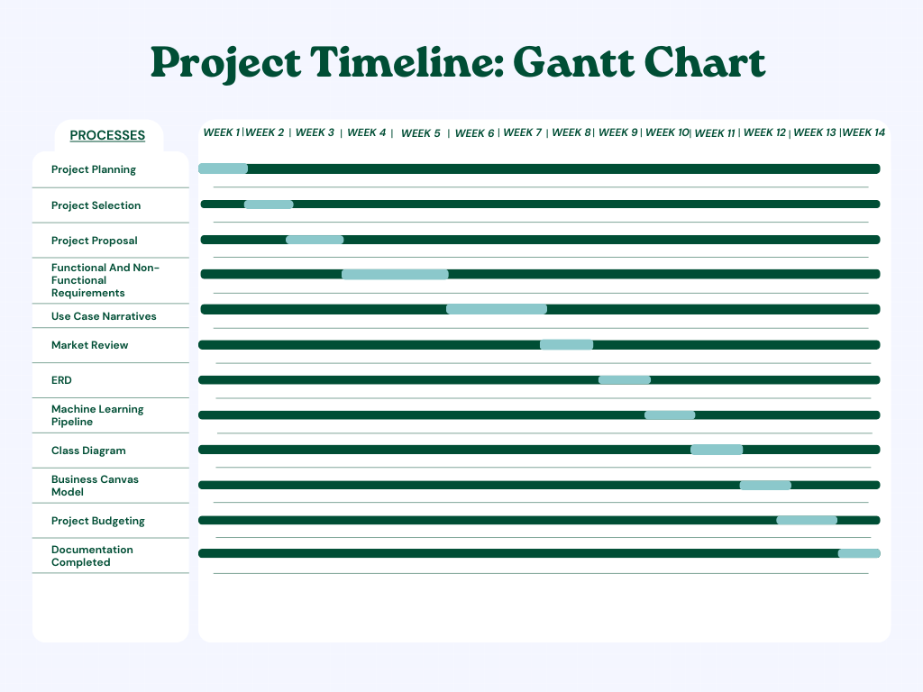

## Machine Learning Pipeline:

